Software Requirements
Specification
for
Smart Web-Based Mock Interview System

Version 1.0 approved

Prepared by
Asfand Yar – 60408
Muhammad Balach – 59524
Mahteer Mohammad - 59684

27-Nov-2025

Table of Contents
Table of Contents ii
Revision History iii
List of Figures iv
List of Tables v
Chapter 1: Introduction 1
1.1 Purpose 1
1.2 Document Conventions 1
1.3 Intended Audience 1
1.4 Product Scope 1
1.5 References 2
Chapter 2: Overall Description 3
2.1 Product Perspective 3
2.2 Product Functions 3
2.3 User Classes and Characteristics 4
2.4 Operating Environment 5
2.5 Design and Implementation Constraints 6
2.6 User Documentation 6
2.7 Assumptions and Dependencies 6
2.7.1 Assumptions 7
2.7.2 Dependencies 7
Chapter 3: External Interface Requirements 8
3.1 User Interfaces 8
3.2 Hardware Interfaces 8
3.3 Software Interfaces 9
3.4 Communications Interfaces 10
Chapter 4: System Features 12
4.1 System Feature 1 12
4.1.1 Description and Priority 12
4.1.2 Stimulus/Response Sequences 12
4.1.3 Functional Requirements 13
4.2 System Feature 2 14
4.2.1 Stimulus / Response Sequences 14
4.2.2 Functional Requirements 14
Chapter 5: Other Nonfunctional Requirements 16
5.1 Performance Requirements 16
5.1.1 Key Performance Requirements 16
5.2 Safety Requirements 16
5.3 Security Requirements 16
5.4 Software Quality Attributes 17
5.5 Business Rules 17
Chapter 6: Logical Designs of System 19
6.1 Use Case Diagrams 19
6.1.1 Use Case Diagram – User 19
6.1.2 Use Case Diagram – Premium User 19
6.1.3 Use Case Diagram – Interviewer 19
6.1.4 Use Case Diagram – Admin 19
6.2 Descriptive Use Cases 21
6.3 Activity Diagram of System 31
6.3.1 Start Mock Interview – User 31
6.3.2 View Detailed Performance Report – User 32
6.3.3 Schedule live Interview – Premium User 33
6.3.4 Conduct Live Interview – Interviewer 34
6.3.5 Manage Users – Admin 35
6.3.6 Manage Subscription – User 36
6.4 Data Flow Diagrams 37
6.4.1 Context Level Diagram 37
6.4.2 Level 1 DFDs 37
6.5 Sequence Diagram 38
6.5.1 Sequence Diagram – User Registration 38
6.5.2 Sequence Diagram – User Login 39
6.5.3 Sequence Diagram - AI Led Mock Interview 40
6.6 Entity Relationship Diagram 41

Name | Date | Reason For Changes | Version

Revision History

List of Figures
Figure 1 - Use Case Diagram 20
Figure 2 - Start Mock Interview Activity Diagram 31
Figure 3 - View Detailed Performance Report Activity Diagram 32
Figure 4 - Schedule/Live Interview Activity Diagram 33
Figure 5 - Conduct Live Inetrview Activity Diagram 34
Figure 6 - Manage Users Activity Diagram 35
Figure 7 - Manage Subscription Activity Diagram 35
Figure 8 - Level 0 DFD 37
Figure 9 - Level 1 DFD 37
Figure 10 - User Registration Sequence Diagram 38
Figure 11 - User Login Sequence Diagram 39
Figure 12 - AI Lead Mock Interview Sequence Diagram 40
Figure 13 - Entity Relationship Diagram 41

List of Tables
Table 1 – Descriptive Use Case Table 21
Table 2 – Descriptive Use Case Table 21
Table 3 – Descriptive Use Case Table 22
Table 4 – Descriptive Use Case Table 22
Table 5 – Descriptive Use Case Table 23
Table 6 – Descriptive Use Case Table 23
Table 7 – Descriptive Use Case Table 24
Table 8 – Descriptive Use Case Table 24
Table 9 – Descriptive Use Case Table 24
Table 10 – Descriptive Use Case Table 25
Table 11 – Descriptive Use Case Table 25
Table 12 – Descriptive Use Case Table 26
Table 13 – Descriptive Use Case Table 26
Table 14 – Descriptive Use Case Table 26
Table 15 – Descriptive Use Case Table 27
Table 16 – Descriptive Use Case Table 27
Table 17 – Descriptive Use Case Table 28
Table 18 – Descriptive Use Case Table 28
Table 19 – Descriptive Use Case Table 28
Table 20 – Descriptive Use Case Table 29
Table 21 – Descriptive Use Case Table 29
Table 22 – Descriptive Use Case Table 30

Introduction

Purpose
This Software Requirements Specification (SRS) document defines the complete functional and non-functional requirements for the Smart Web-Based Mock Interview System (Version 1.0). The purpose of this document is to describe the system’s intended functionality, constraints, and operational environment.
This SRS covers the entire system including:
- AI-based interview sessions
- Speech-to-text functionality
- Facial and voice emotion analysis
- NLP-based answer evaluation
- Feedback reporting engine
- User roles (Free User, Premium User, Interviewer, Admin)

Document Conventions
This SRS follows standard software documentation formatting and conventions.
- Bold text is used for section headings and important terms.
- Italics are used to introduce key concepts or references.
- Functional requirements are listed numerically (e.g., FR-1.1, FR-2.3).
- Non-functional requirements are listed with NFR prefixes (e.g., NFR-1.2).
- All AI modules and datasets are written using proper model naming conventions (e.g., Whisper, mBERT, DeepFace).
- No priority inheritance is assumed; each requirement contains its own priority when necessary.

Intended Audience
This document is intended for:
- Developers: to understand system architecture and module requirements.
- Supervisors: to track scope and verify progress.
- Testers: to design test cases based on defined requirements.
- Students: to understand system features and limitations.
- Documentation Writers: to prepare manuals and user guides.

Product Scope
The Smart Web-Based Mock Interview System is designed to help students and job seekers practice interviews using AI technologies. The system provides:
- Automated AI-led mock interviews
- Speech-to-text transcription in English and Urdu
- Facial expression and voice emotion analysis
- NLP-based evaluation of user answers
- Detailed performance reports with recommendations
- Tiered access: Free and Premium
- Human-led interviews for premium users (future enhancement)
The main objective of the system is to improve employability, reduce interview anxiety, and provide personalized, accessible, and multilingual practice to users.

References
The following references were used during the preparation of this SRS:
- Whisper Speech-to-Text Model, OpenAI - Documentation and API resources.
- FER-2013 Dataset - Facial expression dataset used in emotion classification research.
- RAVDESS Dataset - Ryerson Audio-Visual Database of Emotional Speech and Song.
- mBERT (Multilingual BERT) - Google AI language representation model.
- DeepFace Framework - Open-source facial recognition and emotion analysis toolkit.
- IEEE Software Requirements Specification Standard (IEEE 830).
- React, Flask, and MongoDB official documentation (for development reference).

Overall Description

Product Perspective
The Smart Web-Based Mock Interview System is a new, standalone software product developed to assist job seekers in improving their interview performance through AI-driven analysis. It does not replace any existing institutional system; instead, it introduces an advanced, self-contained digital platform that merges multiple AI technologies speech recognition, facial expression analysis, vocal tone evaluation, and natural language processing into one unified interview training environment.
The system operates as an independent web application, accessible through standard browsers, and communicates with various integrated AI modules such as Whisper for speech-to-text, DeepFace for facial analysis, SER models for vocal tone evaluation, and mBERT for multilingual text processing. These components work together through a central AI Analysis Engine, which takes inputs from the user’s microphone, webcam, and typed information to generate an insightful performance report.
Although future expansions will introduce a Premium tier featuring human interviewers, the core system described in this SRS is self-sufficient and functions without external human-operated platforms. The Premium mode will interface with a video-conferencing module, but this lies beyond the functional scope of the current version.
The diagram below represents the conceptual place of this system within its environment, showing the main subsystems and their interactions:
- User Interface (web app)
- AI Analysis Engine (speech, text, facial, vocal analysis)
- Feedback Engine
- MongoDB Database
- Human Interviewer Interface

Product Functions
The Smart Web-Based Mock Interview System delivers a blend of AI intelligence and user-friendly interaction. At a high level, the system performs the following core functions:
- User Authentication & Dashboard Access
Enables users to register, log in, and view a personalized dashboard displaying interview history and progress.
- AI-Driven Mock Interview Sessions
Generates interview questions based on user-provided skills and job descriptions and allows users to respond through voice.
- Multilingual Speech Processing
Converts spoken answers in Urdu and English into text through integrated speech-to-text models.
- Facial Expression & Voice Emotion Analysis
Captures webcam feed and voice tone to detect confidence, nervousness, engagement, hesitation, and stress.
- NLP-Based Answer Evaluation
Analyzes the meaning, clarity, relevance, and fluency of the user’s spoken responses using advanced language models.
- Feedback Report Generation
Combines non-verbal cues and NLP assessment into a detailed, session-based performance report with personalized improvement tips.
- Data Storage & Progress Tracking
Stores user sessions, reports, and performance metrics for long-term tracking and analysis.
- Premium Interview Module (Future Work)
Allows premium users to schedule live interviews with human interviewers, who provide manual feedback supported by AI analysis.
- Admin Panel
Supports system-level management including user moderation, question-bank updates, and monitoring platform activity.

User Classes and Characteristics
The world of this system is shared by a few different tribes each with their own role, rhythm, and level of power. Every class touches the platform differently, and the system bends itself to meet them where they stand.
1. Free User (Primary User Class)
These are the everyday learner’s students, fresh grads, job hunters trying to sharpen their edge.
- Uses AI-led mock interviews
- Speaks through voice, gets AI-powered feedback
- Tracks growth over multiple sessions
- Needs basic tech comfort, nothing fancy
Why they matter:
They are the heartbeat of the platform the ones who will use it the most and grow with it.
2. Premium User
These are the more serious dream-chasers, the ones ready to invest in themselves.
- Access to human-led interviews with professionals
- Can schedule sessions
- Receives deeper, dual feedback (AI + human)
- Requires slightly more platform interaction
Why they matter:
They represent advanced usage and future expansion not essential now, but critical later.
3. Interviewer (Future Enhancement)
The pros industry folk or trained evaluators stepping in as human mentors.
- Conduct live interviews
- Provides human judgment on answers
- Views AI emotion analysis in their dashboard
- Minimal technical skill needed just communication and clarity
Why they matter:
They elevate the system beyond automation, bringing a human soul to the feedback loop.
4. Admin (Core System Manager)
The ones running the backstage the guardians of data, users, and content.
- Manages user accounts and roles
- Oversees question bank
- Tracks system stats and logs
- Holds the highest privilege and deeper technical familiarity
Why they matter:
They keep the platform alive, clean, and running smooth.

Operating Environment
This system lives fully in a web-based world, breathing through the user's browser and powered by the server running behind the scenes. It doesn’t demand fancy hardware, just the essentials to let the AI listen, see, and respond.
Hardware Environment
- Any device with a microphone and webcam (laptop or desktop recommended).
- Stable internet connection for real-time audio and video processing.
Software Environment
- Runs on any modern web browser:
  - Google Chrome
  - Microsoft Edge
  - Mozilla Firefox
  - Safari
- Backend powered by Flask (Python) for server logic and AI communication.
- Database built on MongoDB, handling user data, interview sessions, and feedback reports.
- AI services run as Python microservices using:
  - Whisper for speech-to-text
  - DeepFace for facial emotion analysis
  - SER model for voice emotion detection
  - mBERT for multilingual NLP processing

Operating Systems Supported
- Windows
- Android / iOS (browser access only)
The system blends into any environment that supports a browser, working quietly alongside other apps without conflict. No installation, no chaos just seamless, web-based interaction.

Design and Implementation Constraints
The volume of real-time, intensive AI processing is the main constraint of the design, which is necessary in a typical and lightweight web browser to activate Speech-to-Text, face, and voice tone analysis. This requires low-latency feedback models that are highly optimized with AI. Security is paramount: to use the webcam and microphone the system should strictly follow the protocols of HTTPS and browsers to enter the web only during the sessions with user permission. Security and Privacy requirements impose limitations on Data handling, which implies using a strong SSL/TLS and at-rest encryption of all data stored in MongoDB. There is a Multilingual Support limitation of the system, where both the English and Urdu language models should use correct STT and NLP models, and RTL should be used to accommodate the Urdu language. In addition, it needs to be modular with the capability to be extended so as to accommodate additional capabilities such as the scheduling and video-conferencing modules of the Premium Tier without a hustle and bustle, based on a critical phased development constraint.

User Documentation
- Contextual On-Screen Help (Tooltips and Pop-ups): Short, interactive help, which is present within the application interface.
- Content: Brief descriptions of complex aspects (e.g., What does the Fusion Model score mean?), instructions on how to enter the skills, instructions on how to manage the user settings.
- Delivery Style: Some tooltips and modals that are activated by the hover of the mouse or a help icon (?).
- Getting Started Guide (User Manual): A brief in-depth manual to use with a first-time user.
- Content: Contains information about registration, setting up the system (testing of microphones/webcams and getting ready to conduct an interview), holding an interview led by AI, and the interpretation of the detailed performance reports.
- Delivery Format: A navigable web page that is hosted in the application (e.g., /help) and a downloadable PDF document (A4 standard) to be used off-line.
- FAQ (Frequently Asked Questions): A dynamic base of knowledge to deal with general troubleshooting.
- Content: Browser compatibility questions, technical problems (e.g Webcam not detected), payment processing the Premium Tier and data privacy policies.
- Delivery Format: A reactive, searchable web page in-built into the platform.

Assumptions and Dependencies
The successful development and operation of this system rely on several key assumptions and external dependencies.

Assumptions
- User Environment Consistency: It is assumed that end-users will access the system using modern, up-to-date web browsers (e.g., Chrome, Firefox, Edge, Safari) that fully support the latest HTML5 standards, including WebRTC for seamless access to the camera and microphone.
- Adequate Hardware: It is assumed that end-users possess functional hardware, specifically a working microphone and webcam, and an internet connection of sufficient bandwidth (minimum 5 Mbps upstream/downstream) to handle the real-time audio and video processing required for AI analysis.
- Future Feature Priority: The development timeline assumes the Premium Tier features (human interviewer management, scheduling, payment gateway integration) will only begin after the core Free Tier AI-led interview functionality is fully stable and launched.

Dependencies
- Third-Party AI Services: The system is critically dependent on external, specialized third-party or commercial components for core functionality. This includes highly accurate Speech-to-Text (STT) models (like Whisper, as noted) capable of supporting both English and Urdu, and robust Natural Language Processing (NLP) services for content evaluation.
- Payment Gateway Integration: The future implementation of the Premium Tier is dependent on the reliable integration with a stable, secure, third-party Payment Gateway (e.g., Stripe, PayPal, or local equivalent) to handle subscription processing and billing.
- Video Conferencing SDK/API: The live interview sessions (Premium Tier) are dependent on a dedicated Real-time Audio/Video SDK or API to handle the conferencing module reliably across different devices and networks.
- Database Scalability: The system depends on the continued reliability and scalability of MongoDB or a comparable NoSQL database service for persistent storage of all session data and performance reports

External Interface Requirements

User Interfaces
The user interface (UI) design of the system will follow a clean minimalist design and a responsive web standard will ensure maximum accessibility and usability across all types of devices (Desktop, tablet and mobile). This design solution is obligatory to meet the non-functional requirement of providing the stress-free environment.
- Basic graphics user interface: This component delivers a minimum of 320 x 480 pixels of graphics display. Basic graphics user interface: This component provides best pixels of graphics display.
- Layout and Responsiveness: Each and every screen has to utilize a fluid layout (responsive grids) to avoid overflow and horizontal scrolling. The design should be flexible particularly to support the Right-to-Left (RTL) scripting needed to display the Urdu language.
- Normal Navigation: There will be a consistent, clean navigation bar that will give regular access to the main modules: Dashboard, Interview History, and Help/FAQ.
- Standard Controls: It has to share a similar look and feel of all interactive elements including buttons, links, and forms. Any help icon (?) will be positioned everywhere and it will be activated to give some contextual assistance tooltips.
- Error Display: System messages, e.g., validation errors and backend errors (e.g. Webcam not detected), will be shown through non-intrusive toast messages, or inline validation messages. Standard browser alert boxes are not to be utilized.

Software Components (Screens/Modules) needed as part of the User Interface:
- Authentication Module: Login and Registration screens of general user, Interviewers and Admins.
- User Dashboard: This is the main dashboard where progress monitoring and new sessions are initiated.
- Session Set-Up Screen: Skills, job description and language set up interface (English/Urdu).
- Interview Session Screen: This is the central interface that shows the question prompt, the live video stream of the user, and a visual representation that the microphone analysis engine is on.
- Feedback/Report Module: This is a detailed and interactive presentation of performance reports, but the NLP Content results and Non-Verbal (Fusion Model) results are separated.
- Admin Panel: Specialized secure user, content, system monitoring interface (as detailed in F.R. 6).
- Premium Scheduling Module: interface to see the availability of interviewers and make live bookings.
- Interviewer Dashboard: This is a specific screen that oversees the assigned sessions and provides human assessments.

Hardware Interfaces
The Smart Web-Based Mock Interview System is coded into a pure web application i.e. its interface with hardware is mediated solely by the operating system of the client and the web browser. There are two major hardware input requirements in the core functional requirements (AI Analysis and Voice-Based Interaction) of the system. Supported Hardware Interfaces Dynamically loaded hardware interfaces, which are supported by code.

Microphone Input:
Supported device types: Any microphone that is recognized as well as any accessible by the operating system such as embedded laptop microphones, external microphones by USB, or embedded headset microphones.
- Interaction: The software interacts with the HTML5 API MediaDevices (in particular, getUserMedia()) to request the audio stream of input.
- Data Flow: Raw audio data is recorded, digitalized (e.g., 16-bit PCM) then continuously transmitted over the network to the back-end AI services to perform real time Speech-to-Text Conversion and Vocal Tone Analysis.
- Protocol: Data sharing will be based on secure encrypted protocols ( HTTPS/ WSS ) and processed using WebRTC (or a close streaming technology with low latency) in both AI-led and Premium (Live) sessions.

Webcam/Camera Input:
- Supported Type of the device: Any internal or external USB camera available through the browser.
- Interaction: Like in the case with the microphone, the system relies on HTML5 MediaDevices API (getUserMedia()) to retrieve the video stream.
- Data Flow: The video stream will be processed on the client-side (where possible, due to efficiency) or streamed safely to the server with Facial Expression Analysis. The analysis captures and process image frames to detect such expressions as confidence, nervousness and engagement.
- Procedure: Secure and encrypted stream transmission (HTTPS/WSS) is required to ensure privacy of the user.
Physical Interface Characteristics:
The software does not interface with hardware drivers or proprietary interfaces. The entire interaction is done at a logical level through a combination of standard browser APIs (WebRTC, MediaDevices API) which hide the physical nature of the devices. The system should incorporate a compulsory check of hardware used during the establishment of a session to make sure these devices are recognized and access is approved before the beginning of an interview.

Software Interfaces
The Smart Web-Based Mock Interview System architecture is configured in a tapered and high-performance design. It possesses interfaces that are compatible with secure and supreme efficient communication between the client side, the application backend, and special external services.
Database Layer Interface
This interface includes Data Persistence (FR 4.4) and Progress Tracking (FR 1.3) mainly. A document database such as MongoDB (NoSQL) is central storage of all operational and analytical data used in the system. The communication takes place through the usual MongoDB Driver API through the obligatory TLS/SSL encryption. The information that is stored would be user profiles, questions hierarchy, and, most importantly, the AI analysis results (structured JSON documents), which would be considered to be truthful in every single session.
An AI-based analytical services interface encompasses big data analytics, deep learning, and machine learning interfaces. AI Analytical Services Interface The AI analytics interface includes big data analytics, deep learning, and machine learning interfaces.
This is the most complicated and mission-critical interface of the system that accommodates the core AI-Powered Analysis Engine (FR 3) and Multilingual Interaction (FR 2.3). It links the rear end with external, specialized AI platforms (including those based on Whisper for STT).
- Input Data: The client transmits high-throughput audio as well as serial video frame safely WebSockets (WSS) or RESTful API on the external AI platforms.
- Processing: These systems do real-time English and Urdu Speech-to-Text (STT) conversion, high-quality Vocal Tone Analysis and Frame-by-Frame Facial Expression Analysis. Answer Evaluation is performed by the NLP Module (FR 3.5), which analyses the text that has been transcribed.
- Output Data: The interface provides the backend with analytical vectors of high-quality contained with confidence scores, emotional state categorizations and content relevance scores.
Video and Audio Conferencing Interface:
The system uses a specific WebRTC SDK/API to support live and human-led Premium sessions (FR 5.3). This interface supports peer-to-peer or relayed communication services that are secure between the user and the interviewer. It deploys the WebRTC protocol in order to guarantee low-latency and real-time streaming and signaling channels are authenticated over the HTTPS/WSS which fulfills the Scheduling Reliability (NFR 4.2) requirement.
Backend Service Layer:
The Application Backend (usually a stable Linux operating system) serves as the control service, and it pulls the external services and offers high performance and authenticated services to the client.
- Interview Service: This service is in charge of the entire flow of the session. It dynamically retrieves queries of the Database, sends user inputs to the AI Services Platform to be analyzed simultaneously, and combines the derived results with the Fusion Model (NFR 3.1) and then stores the resulting metrics onto the DB.
- Reporting Service: This service will execute advanced retrieval instructions to the Database, take raw data that is the result of analytics and generate the completed and well-organized reports on the performance and send them to the client. This guarantees the Distinct Display of Results (NFR 3.2), i.e. fused non-verbal and NLP materials separately.

Communications Interfaces
So, we broke the system comms down into two major segments, which are regular network stuff and live media streaming all under strict security and media performance rules.
General Network Communications.
Any app-level communications between the browser and the backend, such as the login (FR 1.1), the dashboard loading (FR 1.2), and the config data fetch will have to pass through HTTPS.
- Security/Encryption: HTTPS with required TLS, all data is transmitting safely following NFR 5.1 -keeps logins, profiles and reports locked.
- Formatting messages: All of the asynchronous messages, client to backend and service to service, must be in the form of a JSON format since it is lightweight and operates everywhere.
- Sync: The token-based sync (as in JWT) is used to store the user sessions to be safe throughout the entire app.

Live Media and Artificial Intelligence communications:
Real-time AI analysis (FR3) and live interview seshes (FR5.3) have the most difficult comms.
AI data streaming: We data stream continuous high-volume audio/video to the AI services (STT, facial/vocal analysis) using secured WebSockets (WSS) or a similar low-latency stream, maintaining a bidirectional connection with real-time analysis.
- WebRTC to conferencing: The live interview utilizes WebRTC to establish secure P2P or relayed audio/video between the user and interviewer it performs low-latency NFR 2.1 real-time.
- Transfer rates: We must ensure at least 5Mbps/session to ensure that streams are smooth, and the AI is able to analyze correctly under the assumption the correct hardware of assumption 1.3.
- Sync mechanisms: Timestamps are inserted in each audio/video stream- this is the thing. It allows the AI modules (STT, vocal tone, facial expression) to be in complete synchronization to the extent that the Fusion Model (NFR 3.1) spews out a sensible performance report.

System Features

System Feature 1

Description and Priority
This option is the capability of the system to hold automated AI-driven mock interview sessions and schedule human interviewers with feedback. Its functionality allows users to train with real-time voice input in the interview and the system to learn with pre-trained speech, emotion, and facial analysis AI models and provides the user with structured feedback reports.
- Priority Level: High, since it is the essential utility of the project.
Assigned Priority Component Ratings (1-9 Scale):
- Benefit: 9 (direct improvement in interview preparation and skill assessment)
- Fine: 7 (without this, the system is deprived of its primary objective)
- Expense: 6 (combining several AI modules makes the process more complex, but can be handled)
- Risk: 5 (based on the performance of pre-trained models and accuracy of real time fusion)

Stimulus/Response Sequences
- User Action: The user begins speaking their response (in English or Urdu) into the microphone after the AI interviewer poses a question. The webcam stream is simultaneously active.
- System Response (Real-Time Stream Capture): The client application captures the audio and video streams using the MediaDevices API. It then continuously and securely streams the raw audio data and video frames to the backend for AI processing via WebSockets.
- System Response (Concurrent Analysis): The backend immediately initiates three concurrent analytical processes:
  - Speech-to-Text (STT): The audio stream is sent to the multilingual STT service (e.g., Whisper) which converts the spoken words (English or Urdu) into a text transcript.
  - Vocal Tone Analysis: The raw audio stream is analyzed to extract metrics related to pitch, pace, volume, and stress, which are translated into confidence/hesitation scores.
  - Facial Expression Analysis: The video stream frames are processed to detect and classify facial expressions (e.g., neutral, smiling, frowning) and eye contact, translating these into engagement and nervousness scores.
- System Response (NLP Trigger): Once the user stops speaking and the STT process yields the final transcribed answer, the system passes this text, along with the original question, to the NLP Answer Evaluation module.
- System Response (Evaluation Output): The NLP module analyzes the text for relevance, completeness, and clarity, generating a content score and specific textual feedback.
- System Response (Data Synchronization and Fusion): The backend uses timestamps to synchronize the vocal, facial, and NLP results for the entire answer duration. It then applies the Fusion Model to merge the vocal tone and facial analysis scores into a single, comprehensive Non-Verbal Communication assessment.
- System Response (Persistence): The final, fused scores, the NLP evaluation, the transcript, and the session metadata are securely packaged and stored as a structured document in the MongoDB database.
- System Response (Feedback Pipeline): The system notifies the Feedback and Reporting module that analysis for this question is complete, triggering the next phase of the interview or the final report generation.

Functional Requirements
The following requirements ensure the accurate and reliable execution of the Real-Time Non-Verbal and Content Analysis scenario:
- FR-1 (Media Stream Capture): The client application captures raw audio and video input streams from the user’s selected microphone and webcam using the HTML5 MediaDevices API upon the start of a user response.
- FR-2 (Secure Real-Time Streaming): The client application streams the captured raw audio and video data securely via WebSockets (WSS) to the backend analytical service in real-time, embedding accurate timestamps for synchronization.
- FR-3 (Multilingual STT Execution): The backend analytical service utilizes a specialized STT model (e.g., Whisper) to accurately convert the real-time audio stream into text, supporting both English and Urdu languages.
- FR-4 (Facial Expression Quantification): The backend processes the video frames to analyze facial expressions and eye contact, resulting in quantifiable metrics for confidence, nervousness, and engagement.
- FR-5 (Vocal Tone Quantification): The backend analyzes the audio stream to evaluate vocal characteristics (pitch, pace, tone, stress) and translate these into quantifiable scores for clarity and confidence.
- FR-6 (NLP Content Evaluation): Upon receiving the final transcribed answer, the NLP module assess the response for relevance to the original question, fluency, and content completeness, generating a content score and specific feedback.
- FR-7 (Data Synchronization): The backend uses the embedded timestamps to synchronize and align the STT transcript, Vocal Tone metrics, and Facial Expression metrics across the duration of the user's response.
- FR-8 (Fusion Model Application): The backend applies the Fusion Model to combine the results of the Facial Expression and Vocal Tone analyses into a single, comprehensive Non-Verbal Communication Assessment score.
- FR-9 (Error: Hardware Failure Handling): If the client application fails to capture the required audio or video streams after three retry attempts, the system displays an informative, non-intrusive error message ("Hardware not detected. Please check your webcam/microphone settings.") and offer the user the option to reconfigure or terminate the session.
- FR-10 (Error: STT Latency Threshold): The backend ensures that the latency for the Speech-to-Text conversion does not exceed milliseconds after the user stops speaking, to maintain a responsive user experienc.
- FR-11 (Data Persistence): The backend securely packages and store the final Fusion Model score, NLP content score, all individual metrics, the text transcript, and session metadata as a document in the MongoDB database.
- FR-12 (Feedback Trigger): Upon successful completion of all analysis and data persistence, the system triggers the Feedback and Reporting module to generate and display the final performance report.

System Feature 2
This feature allows users to enter their skills and job description, and the system generates relevant interview questions automatically. It uses AI (mBERT + LLMs support) to understand the input and map it to the question bank or dynamically generate new ones. The goal is to give personalized questions instead of fixed, generic interview questions.
- Priority Level: High personalized questioning is a core requirement for delivering meaningful practice.
Priority Component Ratings (1–9 Scale):
- Benefit: 9 → Makes interview practice targeted and realistic for different job domains.
- Fine/Penalty: 7 → Without personalization, the system becomes a generic Q&A mock interview tool.
- Expense: 5 → Uses lightweight AI inference rather than expensive model training.
- Risk: 4 → Low risk since it relies on pre-trained multilingual understanding instead of manual question mapping.

4.2.1 Stimulus / Response Sequences
- User Stimulus: The user enters skills and a job description in the input form.
- System Response (Text Understanding): The backend analyzes the input using mBERT to understand language + intent (English/Urdu).
- System Response (Question Mapping):
  - Searches the existing question database for relevant tagged questions OR
  - Sends input context to the question generation model if unique questions are needed.
- System Response (Output Delivery): The generated/mapped list of interview questions is returned to the frontend and displayed to the user.
- System Response (Session Start Enable): The interview session becomes ready to launch using these questions.

4.2.2 Functional Requirements
- FR-1 (Skill & JD Input): The system allow users to input their skills and job description in text form.
- FR-2 (Multilingual Understanding): The backend process input using mBERT to support both Urdu and English.
- FR-3 (Question Database Access): The system fetch skill-relevant questions from MongoDB using tagged skill identifiers.
- FR-4 (Dynamic Question Generation): If questions exist but lack uniqueness, the system generate enhanced questions using AI context understanding.
- FR-5 (Low Latency Delivery): The question generation process completes fast enough to maintain smooth UX inside the browser.
- FR-6 (Error Handling): If AI fails to generate questions, the system falls back to the closest category of existing questions and inform the user non-intrusively.

Other Nonfunctional Requirements

Performance Requirements
The system must deliver real-time AI analysis with minimal delay to maintain a smooth interview experience. Speech input must be transcribed quickly using Whisper, while facial and voice emotion detection run simultaneously. The system should generate feedback immediately after each answer.

Key Performance Requirements
- STT Processing Time: Speech-to-text output must be generated within 2–4 seconds after the user stops speaking.
- Facial Emotion Detection Latency: Webcam frame analysis must run at ~20–30 FPS for near real-time emotion detection.
- Voice Emotion Response Delay: Emotion analysis from speech must be completed in 1–3 seconds after transcription.
- Feedback Report Generation: Combined AI feedback must appear in ≤5 seconds after answer submission.
- API/Server Response Time: Backend request handling should remain ≤200–400 ms for normal operations.
- Maximum System Tolerance: Interview flow must not freeze; if delays occur, partial feedback should be shown instead of waiting for all models.

Safety Requirements
Keeping your data, audio, and video streams safe matters. Nobody wants their personal info floating around, getting misused, or turning a simple practice session into a headache.
- Device Access: The system only asks for your camera or mic if you say yes first. No surprises.
- Data Protection: It won’t save your audio or video in plain form. If it does need to keep anything, it’s encrypted or you’ve given the green light.
- Feedback Tone: The AI keeps things friendly and professional. You’ll get useful feedback, but never rude or harsh comments. Nobody needs that kind of negativity.
- Unauthorized Access: The admin panel and APIs stay locked up tight. Only people with the right credentials get in.
- Failure Handling: If something goes wrong maybe your mic cuts out or the AI hiccups the system just ends the session smoothly and tells you what’s up. No crashing, no drama.
- Privacy: When it comes to recording interviews or writing up reports, the platform follows standard privacy rules. No funny business.
- Malicious Input: If you try feeding it scripts or anything dangerous, the system just blocks it. Nothing harmful gets through.

Security Requirements
Protecting user identities and keeping interview data safe isn’t optionality’s the core of how this system works. No shortcuts here. If users can’t trust the platform, nothing else matters.

Security & Privacy Requirements
- User Authentication: Everyone logs in securely, whether they’re a user, interviewer, or admin. Credentials stay encrypted, always.
- Admin Access: Only verified admins get through. No authentication token, no entry.
- Encrypted Storage: All interview results and feedback go straight into encrypted database entries in MongoDB. Nothing sits around unprotected.
- Private Media: The system never stores raw webcam or microphone files unless they’re encrypted and the user says it’s okay.
- API Security: The backend locks down APIs with security headers and request validation, so only the right people can get in.
- Data Privacy: User privacy comes first. The system handles personal details and analysis data with care from end to end.
- No Public Exposure: No one outside the system ever sees interview data, emotion analysis, or transcripts. Everything stays private.
- Safe Fallback: If security slips up, the system shuts things down fast. It never just leaves things open.

Software Quality Attributes
The platform needs to deliver solid software quality, covering learning, real-time AI help, and setting the stage for future commercial use.
Quality Requirements
- Usability (High Priority): The interface should feel natural users get into an interview in three steps or less. In tests, at least 85% of people need to say they’re satisfied.
- Reliability: Keep uptime at 95% or better. If something goes wrong with input or devices, the system recovers on its own no need for a full restart.
- Correctness: AI transcriptions stay accurate, hitting at least 90% for both Urdu and English responses.
- Flexibility: You can roll out module updates every sprint, and you won’t have to mess with the database schema.
- Interoperability: AI microservices talk to each other using APIs or WebSockets, and syncing shouldn’t take longer than 300 milliseconds.
- Maintainability: Stick to a clean MVC structure so adding new features never takes more than a 20% refactor.
- Portability: The web app works smoothly on any modern browser, no matter the operating system.
- Robustness: Media stream processing shouldn’t crash under normal load. The system supports multiple AI inference calls at the same time.
- Testability: Every module AI services, frontend, backend, and database needs at least 70% unit and integration test coverage.
- Adaptability: The system’s ready to handle more languages down the road. Multilingual LLM or NLP models get added in, but the core logic stays the same no retraining needed.

Business Rules
- The Smart Web-Based Mock Interview System splits up access and responsibilities based on user roles.
- Users on the free tier can jump into AI-led interviews, answer questions by speaking, and get reports on how they did from the AI.
- Premium users (that’s coming soon) will get more. They’ll be able to schedule live interviews, join them, and receive detailed feedback not just from the AI, but from real people too, including reports that look at non-verbal cues.
- Interviewers (also coming later) will handle those live interviews, score answers themselves, and check out AI insights on things like emotion once a session wraps up.
- Admins? They’re in charge of everything managing users, keeping the question bank fresh, checking analytics, and protecting the system’s data and security.
- The AI modules don’t act on their own. They just analyze responses and create feedback, nothing more.
- Every action needs secure authentication, and the system blocks any unauthorized peeking or data leaks.
- All these rules shape how the system gets built. They mean strong access control, special dashboards for each role, secure APIs, and robust data protection all baked in from the start.

Logical Designs of System

Use Case Diagrams

Use Case Diagram – User
The User is the typical candidate that will use the platform to train and rehearse his interview skills. This is the main player of the system.
Interaction: They are in touch with the basic AI features. They start by registering and making a log-in after which they enter their respective skills and job descriptions to customize the experience.
Major Operations: Starting AI-powered mock interviews and answering questions with voice and checking their progress with feedback reports and an individual dashboard are their key operations.

Use Case Diagram – Premium User

Premium User is a premium of the regular User. They possess all the abilities that a typical user could have with the added higher-level features.

Role: This character is a candidate that has paid to take a more comprehensive course.

Major Activities: They may schedule and do live interviews with human professionals on top of regular AI interviews. They also make subscription payments and receive access to Premium Interview Reports that presumably provide more analytics than the standard feedback.

Use Case Diagram – Interviewer
The Interviewer is a human expert or professional in the field of the subject matter, unlike the AI system.
Role: They will oversee holding the real-time, live interview sessions which are booked by Premium Users.
Important Actions: They open an Interviewer Dashboard to control their actions. Their main role is to interview in real-time and offer human feedback, which will offer qualitative data that the AI may overlook.

Use Case Diagram – Admin
The admin is the system administrator that handles the administration of the backend and the general well-being of the platform.
Role: They do not take part in interviews, rather than that, they monitor the entire ecosystem to make sure that everything is running smoothly.
Major Actions: They can access the information in the system fully. This will involve the management of user accounts (standard and premium), conducting interviews to maintain quality, setting up subscription plan, and monitoring the system using the Admin Dashboard.
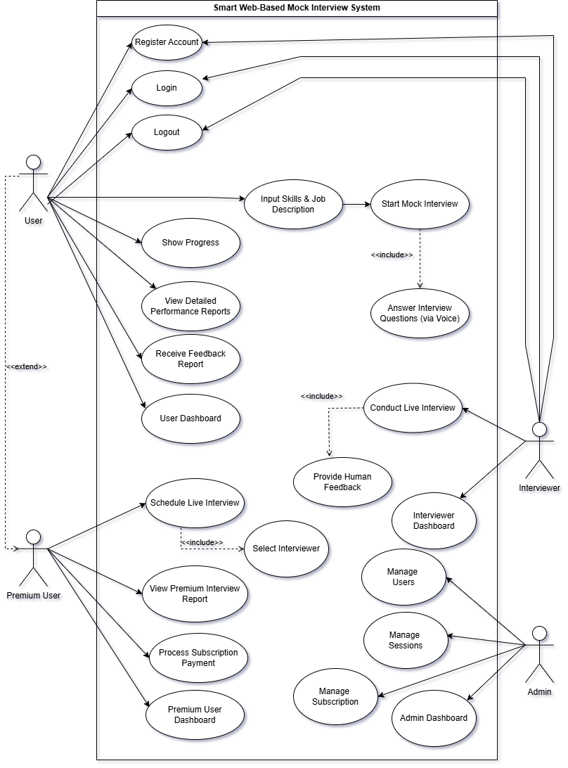
Figure 1 - Use Case Diagram

Descriptive Use Cases
Table 2 – Descriptive Use Case Table
ID: | Use Case 1
Title: | Register Account
Description: | Allow a new user to create an account in the system.
Primary Actor: | User
Preconditions: | User must have valid email/mobile and access to internet.
Post conditions: | User account is created and stored in the database.
Main Success Scenario: | 1.User opens registration page.  2. User enters required details.  3. System verifies inputs.  4. Account is created.  5. User receives confirmation.
Alternative Scenario: | Invalid email or password format.  Email already exists.  Server error.
Frequency of Use: | Occasional (once per user).
Table 2 – Descriptive Use Case Table
ID: | Use Case 2
Title: | Login
Description: | Allows users to authenticate and access their dashboard.
Primary Actor: | User
Preconditions: | Users must be registered.
Post conditions: | User is logged into the system.
Main Success Scenario: | 1. User opens login page.  2. Enters credentials.  3. System verifies.  4. User dashboard loads
Alternative Scenario: | Wrong password.  Account not found.  Account blocked.
Frequency of Use: | Frequent.
Table 3 – Descriptive Use Case Table
ID: | Use Case 3
Title: | Logout
Description: | Ends the active session of the user.
Primary Actor: | User
Preconditions: | User must be logged in.
Post conditions: | Session terminated.
Main Success Scenario: | 1. User clicks logout.  2. System ends session.  3. User is redirected.
Alternative Scenario: | • Session timeout.  • Connection lost.
Frequency of Use: | Frequent.
Table 4 – Descriptive Use Case Table
ID: | Use Case 4
Title: | Input Skills and Job Description
Description: | User enters job role and skills to customize interview.
Primary Actor: | User
Preconditions: | User must be logged in.
Post conditions: | System stores preferences and prepares relevant questions.
Main Success Scenario: | 1. User inputs skills.  2. Inputs job role.  3. System validates.  4. Data saved.
Alternative Scenario: | • Missing fields.  • Invalid job title.
Frequency of Use: | Moderate.

Table 5 – Descriptive Use Case Table
ID: | Use Case 5
Title: | Start Mock Interview
Description: | Initiates the AI-based interview session.
Primary Actor: | User
Preconditions: | Skills/job details must be provided..
Post conditions: | System begins asking questions.
Main Success Scenario: | 1. User selects start.  2. System loads questions.  3. Recording begins.
Alternative Scenario: | • Microphone not detected.  • Network failure.
Frequency of Use: | High.
Table 6 – Descriptive Use Case Table
ID: | Use Case 6
Title: | Answer Interview Questions
Description: | User speaks answers, system transcribes and analyzes.
Primary Actor: | User
Preconditions: | Mock interview must be active.
Post conditions: | User responses captured and analyzed.
Main Success Scenario: | 1. System asks question.  2. User answers.  3. Whisper transcribes.  4. NLP analyzes answer.
Alternative Scenario: | • Poor audio.  • User skips question.
Frequency of Use: | High.

Table 7 – Descriptive Use Case Table
ID: | Use Case 7
Title: | Show Progress
Description: | Displays user’s performance and improvement history.
Primary Actor: | User
Preconditions: | User must have past interview data.
Post conditions: | Progress displayed.
Main Success Scenario: | - User clicks progress  - System loads charts and overview.
Alternative Scenario: | No data available.
Frequency of Use: | Moderate.
Table 8 – Descriptive Use Case Table
ID: | Use Case 8
Title: | View Detailed Performance Report
Description: | Displays full AI analysis including emotions, tone, clarity, relevance.
Primary Actor: | User
Preconditions: | Interview session must be completed.
Post conditions: | Progress displayed.
Main Success Scenario: | System loads complete report.
Alternative Scenario: | Report unavailable.
Frequency of Use: | Moderate.
Table 9 – Descriptive Use Case Table
ID: | Use Case 9
Title: | Receive Feedback Report
Description: | System provides AI-generated feedback after interview.
Primary Actor: | User
Preconditions: | System must finish analysis.
Post conditions: | Feedback delivered.
Main Success Scenario: | Report generated  displayed  saved.
Alternative Scenario: | Server delay.
Frequency of Use: | High.
Table 10 – Descriptive Use Case Table
ID: | Use Case 10
Title: | User Dashboard
Description: | Main interface showing features, reports, and interviews.
Primary Actor: | User
Preconditions: | Login.
Post conditions: | Dashboard opens.
Main Success Scenario: | System loads full dashboard.
Alternative Scenario: | • Dashboard fails to load.
Frequency of Use: | Very Frequent.
Table 11 – Descriptive Use Case Table
ID: | Use Case 11
Title: | Schedule Live Interview
Description: | Premium user books a session with a human interviewer.
Primary Actor: | Premium User
Preconditions: | User must be premium.
Post conditions: | Interview schedule stored.
Main Success Scenario: | User selects date  system books slot.
Alternative Scenario: | • Slot unavailable.  • Payment expired.
Frequency of Use: | Moderate.
Table 12 – Descriptive Use Case Table
ID: | Use Case 12
Title: | Select Interviewer
Description: | Premium user chooses from available interviewers.
Primary Actor: | Premium User
Preconditions: | Must have active premium subscription.
Post conditions: | Selected interviewer assigned.
Main Success Scenario: | List loads  user selects  confirmation saved.
Alternative Scenario: | • Interviewer not available.
Frequency of Use: | Low–Moderate.
Table 13 – Descriptive Use Case Table
ID: | Use Case 13
Title: | View Premium Interview Report
Description: | User views feedback from human interviewer.
Primary Actor: | Premium User
Preconditions: | Completed live interview.
Post conditions: | Report displayed.
Main Success Scenario: | System loads report.
Alternative Scenario: | • Report not uploaded yet.
Frequency of Use: | Moderate.
Table 14 – Descriptive Use Case Table
ID: | Use Case 14
Title: | Process Subscription Payment
Description: | Handles payment for premium subscription.
Primary Actor: | Premium User
Preconditions: | Internet + valid payment details.
Post conditions: | Subscription activated.
Main Success Scenario: | User pays  system verifies  subscription activated.
Alternative Scenario: | • Payment failed.  • Card declined.
Frequency of Use: | Occasional.
Table 15 – Descriptive Use Case Table
ID: | Use Case 15
Title: | Premium User Dashboard
Description: | Special dashboard with premium features.
Primary Actor: | Premium User
Preconditions: | User must have premium account.
Post conditions: | Dashboard opens.
Main Success Scenario: | Loads premium features.
Alternative Scenario: | • Subscription expired.
Frequency of Use: | Frequent.
Table 16 – Descriptive Use Case Table
ID: | Use Case 16
Title: | Conduct Live Interview
Description: | Human interviewer conducts real-time session.
Primary Actor: | Interviewer
Preconditions: | Session must be scheduled.
Post conditions: | Interview completed.
Main Success Scenario: | Interviewer joins → conducts interview → submits notes.
Alternative Scenario: | • Interviewer unavailable.  • User doesn't join.
Frequency of Use: | Moderate.
Table 17 – Descriptive Use Case Table
ID: | Use Case 17
Title: | Provide Human Feedback
Description: | Interviewer uploads evaluation report.
Primary Actor: | Interviewer
Preconditions: | Live interview completed.
Post conditions: | Feedback saved and shared.
Main Success Scenario: | Feedback entered  submitted  stored.
Alternative Scenario: | • Delay in writing report.
Frequency of Use: | Moderate.
Table 18 – Descriptive Use Case Table
ID: | Use Case 18
Title: | Interviewer Dashboard
Description: | Shows upcoming interviews, feedback panel, profile info.
Primary Actor: | Interviewer
Preconditions: | Interviewer login.
Post conditions: | Dashboard displayed.
Main Success Scenario: | Dashboard loads.
Alternative Scenario: | • Technical error.
Frequency of Use: | Frequent.
Table 19 – Descriptive Use Case Table
ID: | Use Case 19
Title: | Manage Users
Description: | Admin controls user accounts, status, permissions.
Primary Actor: | Admin
Preconditions: | Admin login.
Post conditions: | User info updated.
Main Success Scenario: | Admin edits/deletes/updates user account.
Alternative Scenario: | • Unauthorized attempt blocked.
Frequency of Use: | Occasional.
Table 20 – Descriptive Use Case Table
ID: | Use Case 20
Title: | Manage Interview Sessions
Description: | Admin monitors system-wide AI & human interview sessions.
Primary Actor: | Admin
Preconditions: | Admin login.
Post conditions: | Session changes saved.
Main Success Scenario: | Admin views, updates, or deletes sessions.
Alternative Scenario: | Session data missing.
Frequency of Use: | Occasional.
Table 21 – Descriptive Use Case Table
ID: | Use Case 21
Title: | Manage Subscription
Description: | Admin oversees premium subscription plans and payments.
Primary Actor: | Admin
Preconditions: | Admin login.
Post conditions: | Subscription details updated.
Main Success Scenario: | Admin edits plans or resolves issues.
Alternative Scenario: | Payment gateway offline.
Frequency of Use: | Occasional.
Table 22 – Descriptive Use Case Table
ID: | Use Case 22
Title: | Admin Dashboard
Description: | Central control panel for admin operations.
Primary Actor: | Admin
Preconditions: | Admin login.
Post conditions: | Dashboard displayed.
Main Success Scenario: | Dashboard loads fully.
Alternative Scenario: | System error.
Frequency of Use: | Regular.

Activity Diagram of System

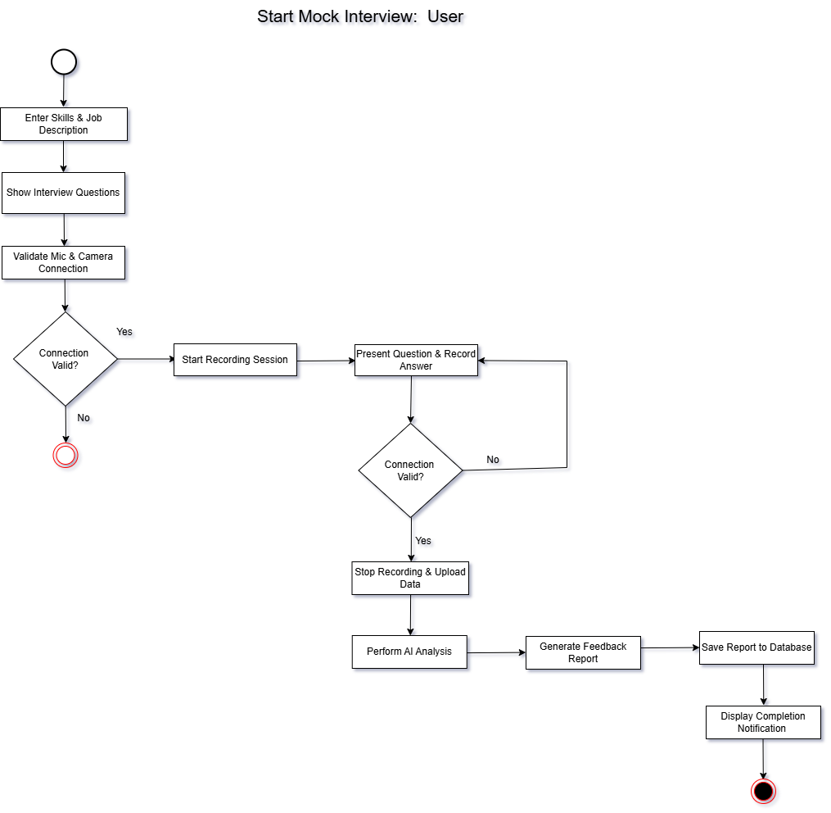
Start Mock Interview – User

Figure 2 - Start Mock Interview Activity Diagram

View Detailed Performance Report – User
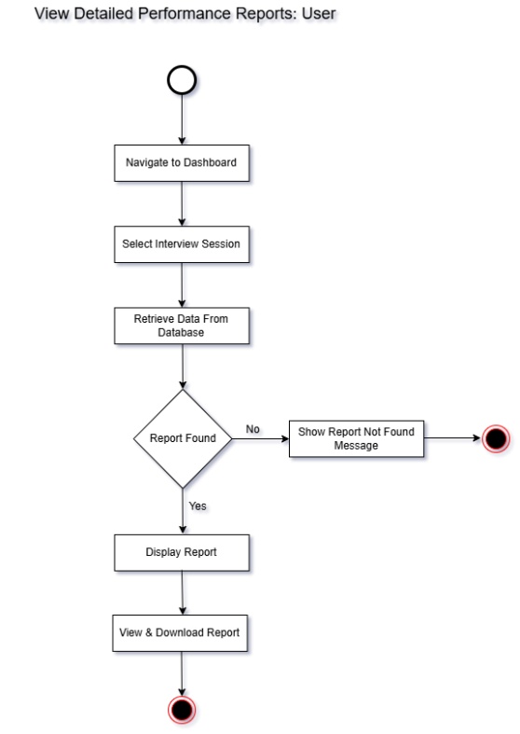
Figure 3 - View Detailed Performance Report Activity Diagram

Schedule live Interview – Premium User
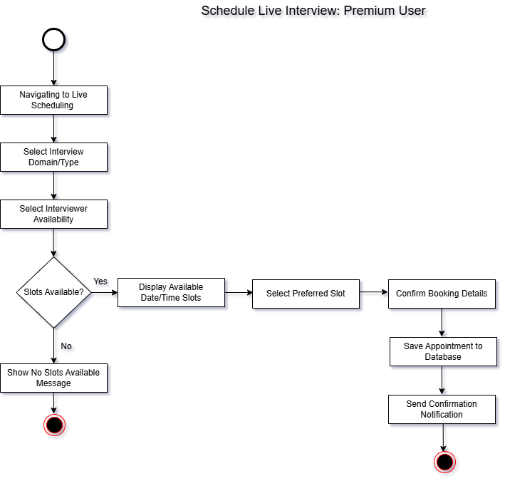
Figure 4 - Schedule Live Interview Activity Diagram

Conduct Live Interview – Interviewer
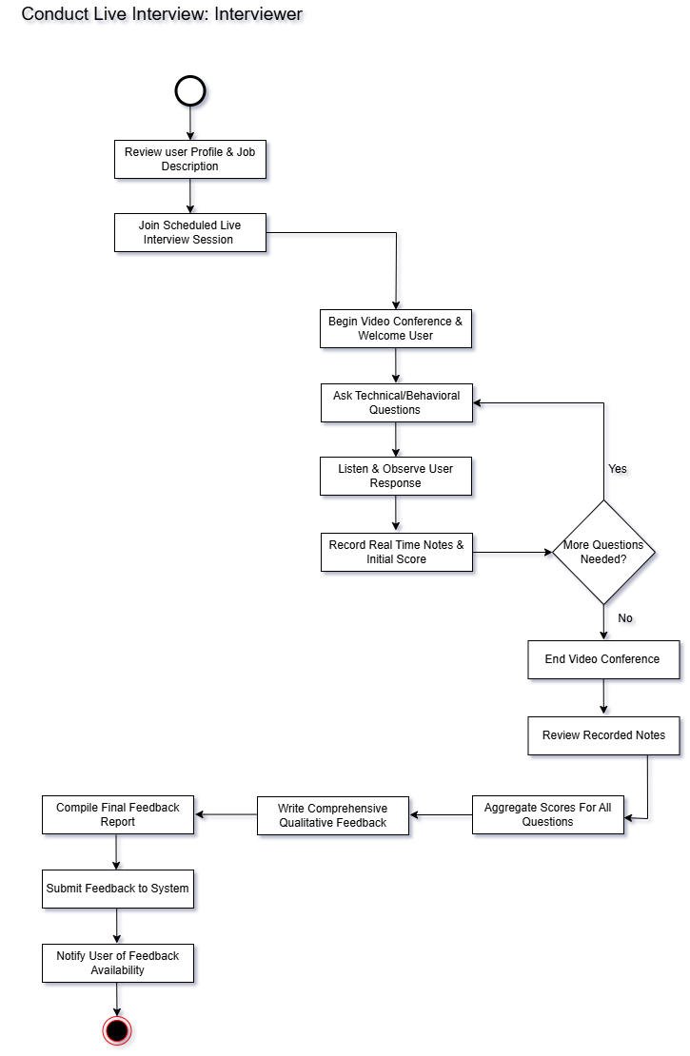
Figure 5 - Conduct Live Interview Activity Diagram

Manage Users – Admin
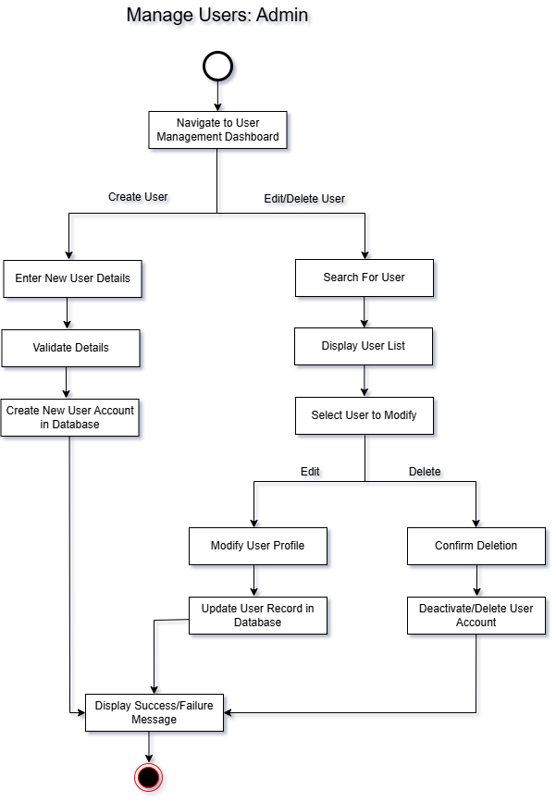
Figure 6 - Manage Users Activity Diagram

Manage Subscription – User
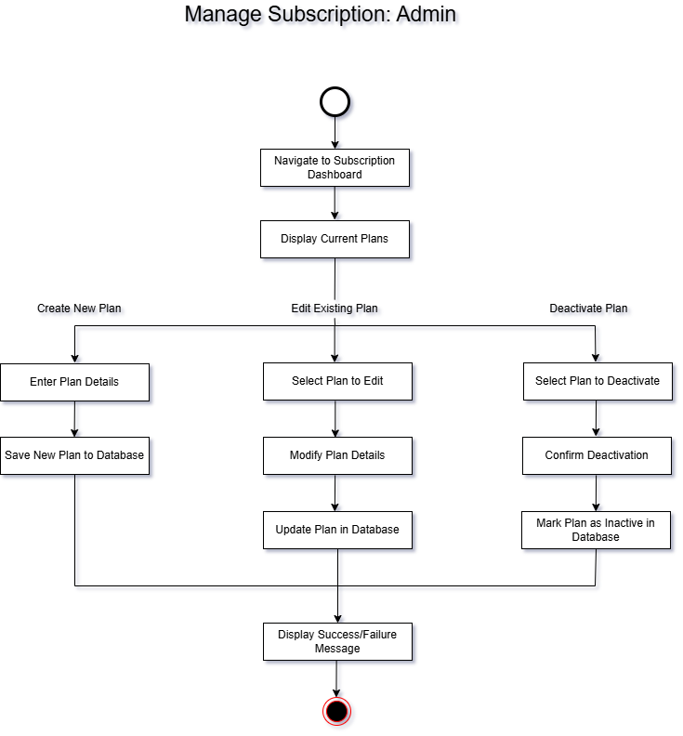
Figure 7 - Manage Subscription Activity Diagram

Data Flow Diagrams

Context Level Diagram

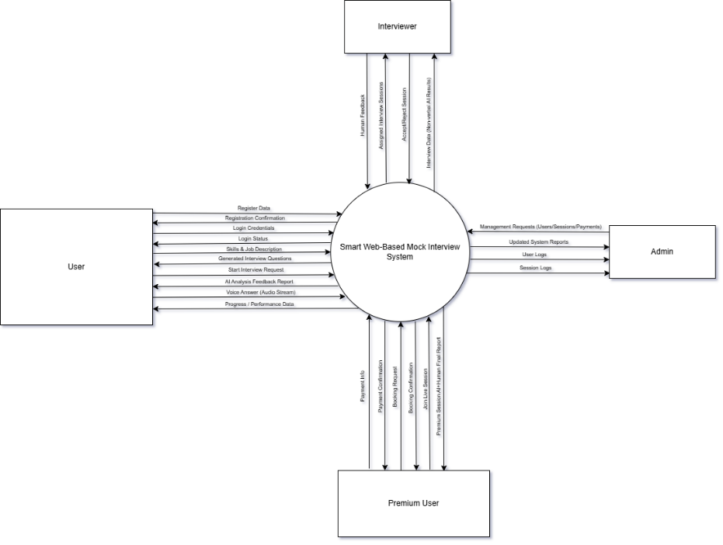
Figure 8 - Level 0 DFD

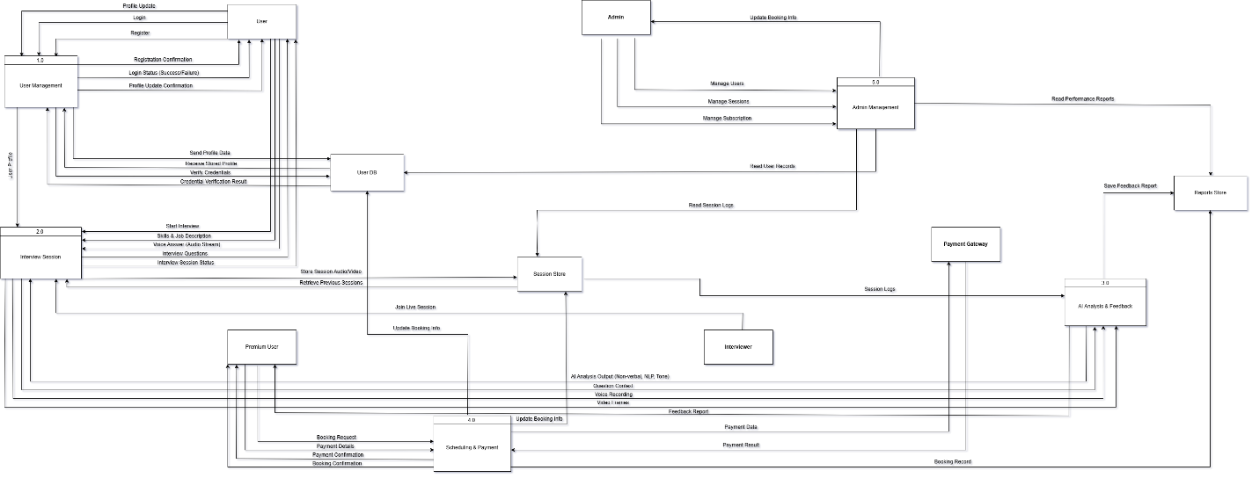
Level 1 DFDs
Figure 9 - Level 1 DFD

Sequence Diagram

Sequence Diagram – User Registration
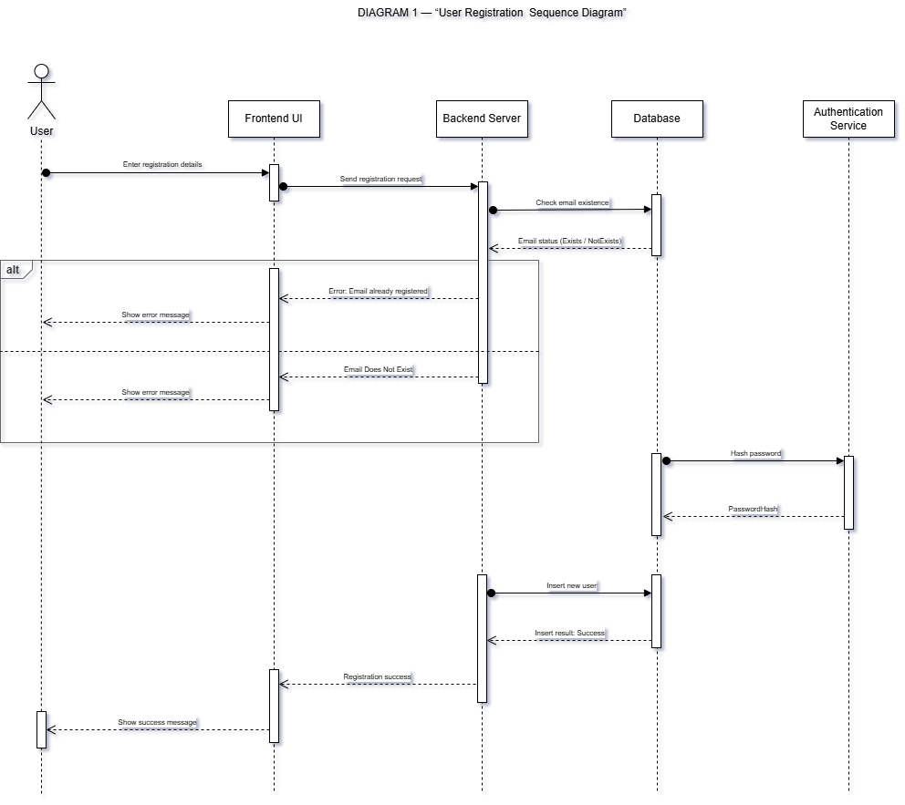
Figure 10 - User Registration Sequence Diagram

Sequence Diagram – User Login
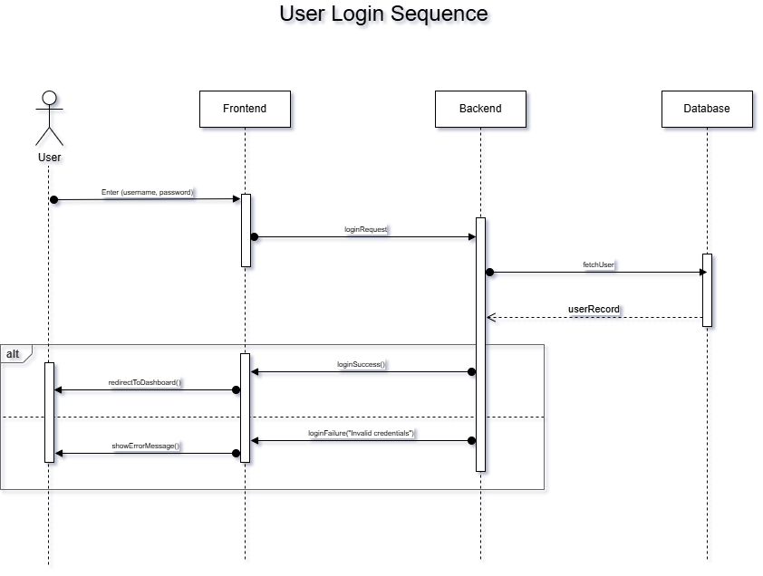
Figure 11 - User Login Sequence Diagram

Sequence Diagram - AI Led Mock Interview
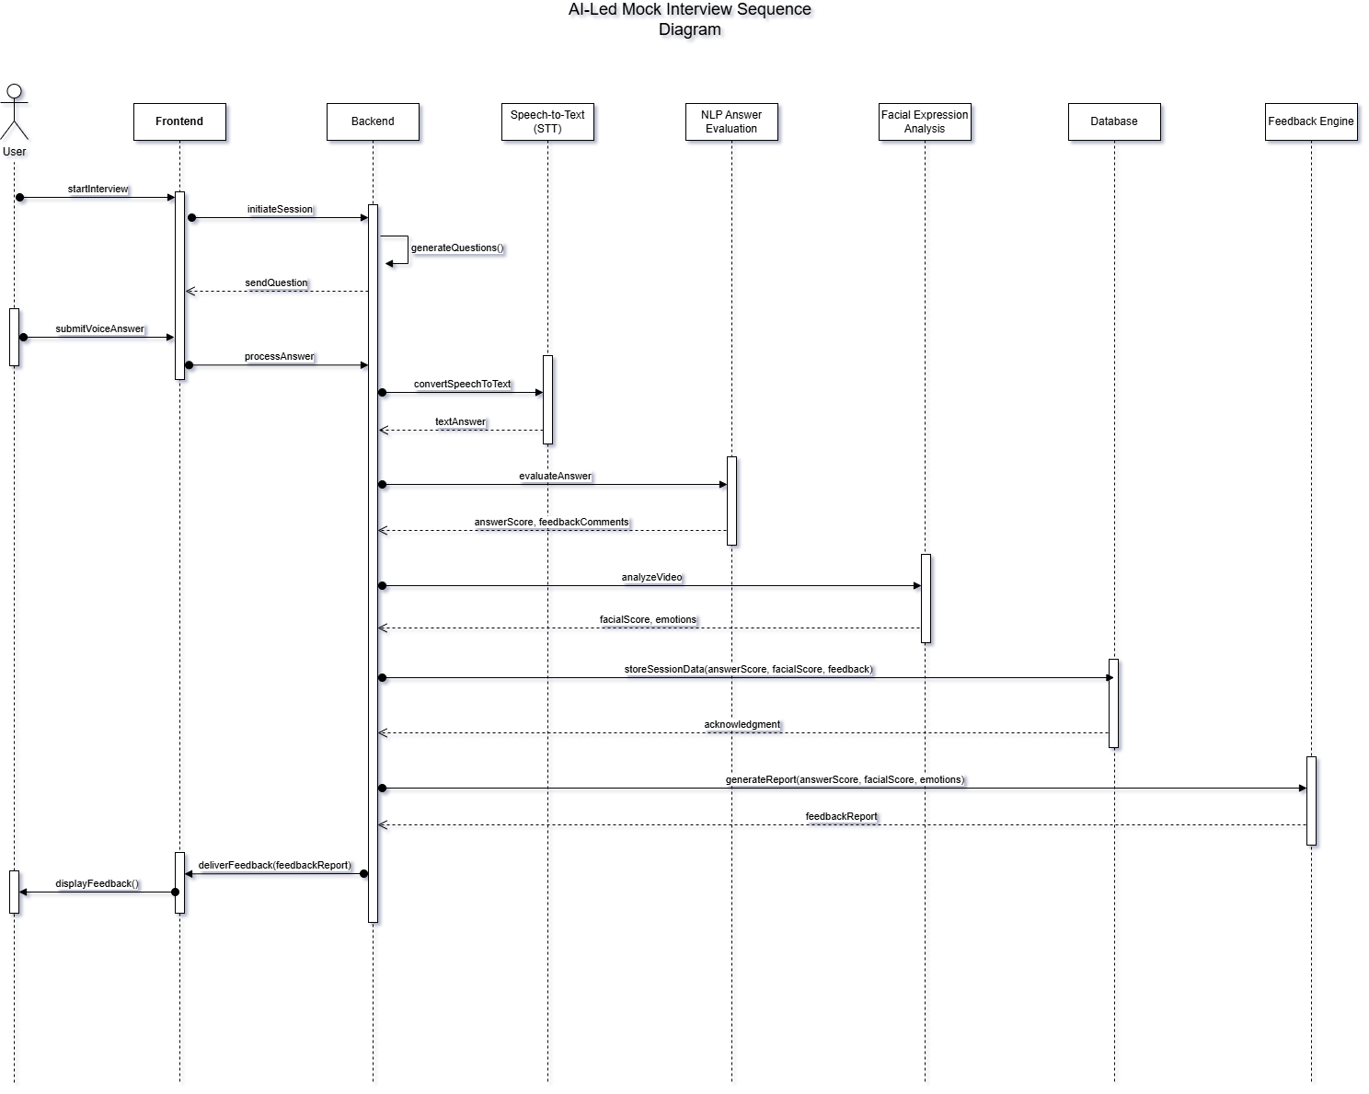
Figure 12 - AI Led Mock Interview Sequence Diagram

Entity Relationship Diagram
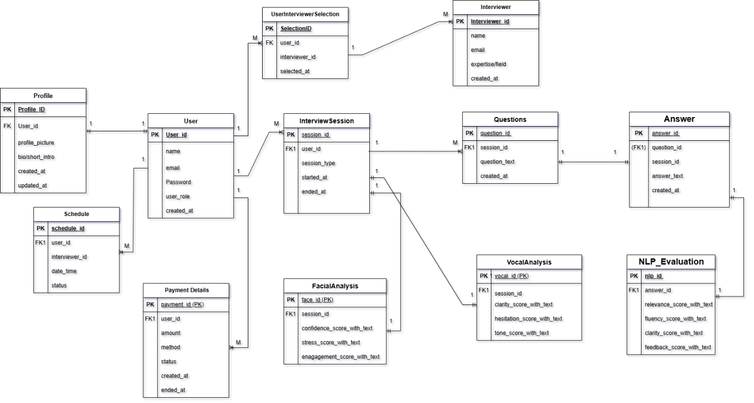
Figure 13 - Entity Relationship Diagram

